 | Australian Federation of Modern Language Teachers Associations Inc. (AFMLTA) and DEEWR  Professional Standards Project (PSP)  National Professional Learning Program 2010 | 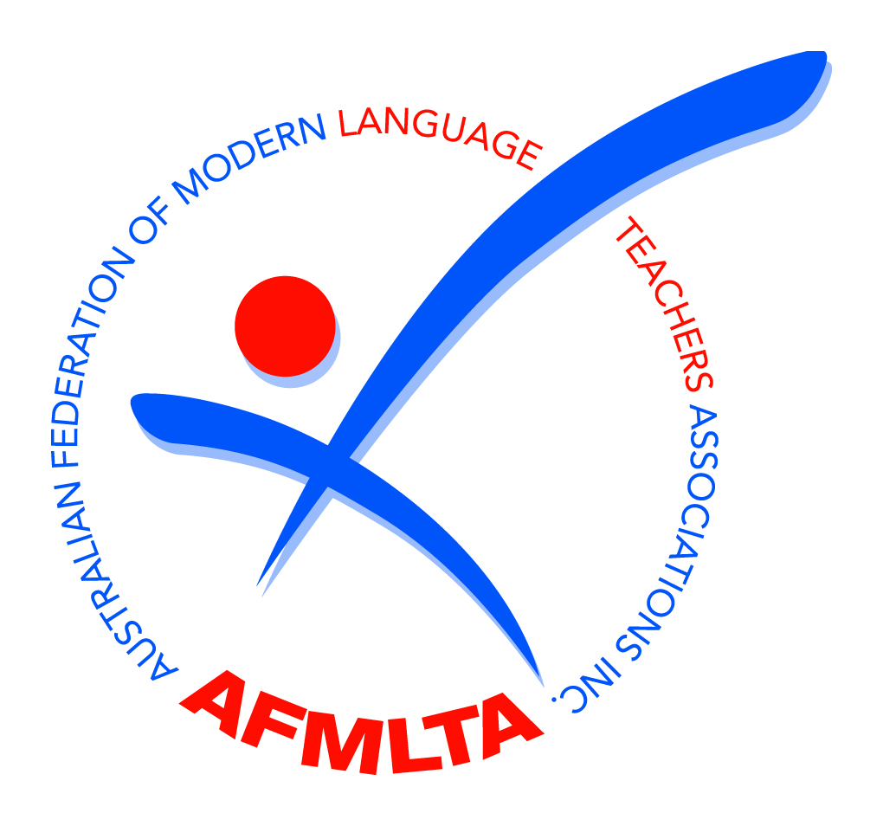
Invitation to participate in Stream C

Registrations are invited from teachers to participate in Stream C of the Professional Standards Project professional learning program

The AFMLTA and DEEWR, together with the Research Centre for Languages and Cultures Education (RCLCE) at the University of South Australia, are inviting teachers to participate in a national professional development programme using the Professional standards for accomplished teaching of languages and cultures developed by the AFMLTA as a framework to update and extend your knowledge and skills in languages teaching.

Benefits of the program include:
- networking and collaborating with teachers of languages in your state or territory on using the Standards in your professional practice
- having access to ongoing support throughout the professional development program
- learning how to use the Standards in teaching your particular language
- being stimulated by reflecting on professional knowledge and practice and to develop self assessment skills
- increasing your capacity to engage with students in collaborative construction of their learning area knowledge and understanding
- gaining a greater awareness of how to develop the attributes and capabilities embodied in the Standards

PSP Stream C in the ACT
Dates: Thursday, 13 May 2010 @ 8.30-4.30 , room MR7(Day 1),
Friday, 21 May 2010 @ 12.00-4.30 room MR7 (Day 2)
Wednesday, 9 June 2010 @ 12.00-4.30 room MR8 (Day 3)

Venue: Centre for Teaching and Learning (CTL), 51 Fremantle Drive STIRLING ACT 2611

This program is open to all teachers who had funded places for PSP Stream A. Funding is available for 1 day of teacher release only. In order to claim this day of release attendance at both days of training is required.

Stream C is an in-depth exploration of assessment, consisting of 4 modules that will:
- situate assessment practices in the context of educational change and current curriculum and assessment frameworks;
- consider assessment as, of and for a focus of learning, as well as the diversity of assessment practices; and
- provide tools for evaluating assessment tasks and collecting evidence of learning.

If you have any queries regarding this project, please contact the PSP MLTA Key Contact for ACT: Meri Dragicevic, meri.dragicevic@ed.act.edu.au

Please send your completed registration form (see over) to your state Key Contact: Meri Dragicevic as soon as possible. Closing date for registrations is Wednesday, 5 May 2010.

PSP Key Contact – ACT:  Meri Dragicevic  President, MLTA ACT Inc  Address:  Yarralumla Primary School  Loftus Street, Yarralumla ACT 2600  NOTE: Enrolment is also possible via the Professional Learning Calendar. | Email: meri.dragicevic@ed.act.edu.au  Ph: 6205 5766  Fax: 6205 5746


PSP Registration – Participation in Stream C

Name
*School/
Place of Work
Address
Telephone | Work: Mobile: Fax:
Email
Language
Level(s) taught
Current  Member of State MLTA? | Yes No (please circle) | Member of Single Language Association(s)? | (if yes, please name)

*Participants are required to be currently engaged in language(s) teaching or consulting

The following data collection is a requirement under the DEEWR funding agreement through which the PSP is funded. Please complete all sections, ticking the appropriate boxes. All information collected is strictly confidential.

Gender
Male
Female
Number of years teaching languages
Up to 5 years
6 to 10 years
11 to 20 years
More than 20 years
School type
P-12
Early years
Primary
Middle
Secondary
Senior secondary
Special
School location
Metropolitan
Regional
Rural/remote
School sector
Government
Catholic
Independent
Ethnic [Community Languages] School
Other employment within the languages consulting area

Dates: Thursday, 13 May 2010 @ 8.30-4.30, room MR7(Day 1),
Friday, 21 May 2010 @ 12.00-4.30 room MR7 (Day 2)
Wednesday, 9 June 2010 @ 12.00-4.30 room MR8 (Day 3)
Venue: Centre for Teaching and Learning (CTL), 51 Fremantle Drive STIRLING ACT 2611

Participant’s signature: ………………………………………Date:…………………….

- Please send your registration for participation in Stream C of the PSP in the ACT.
This form can be posted or emailed to the PSP Key Contact:

Meri Dragicevic, President MLTA ACT Inc
Yarralumla Primary School
Loftus Street, Yarralumla ACT 2600
Ph: 6205 5766 / Fax: 6205 5746
meri.dragicevic@ed.act.edu.au

This project is funded by the Australian Government Department of Education, Science and Training under the School Languages Programme

