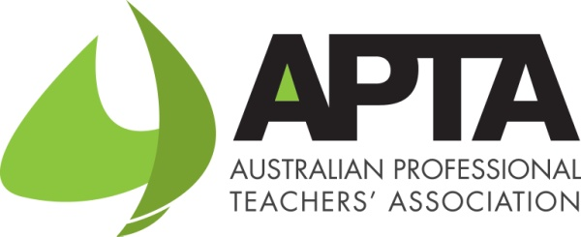 | THE 2015 APTAS

Australian Professional Teachers’ Association

The Australian Professional Teachers Association’s awards acknowledge the exemplary innovation and leadership carried out by individuals and associations who have made outstanding contributions as volunteers to the work undertaken by professional teaching associations.

To assist the APTA Awards Committee, APTA encourages state and territory joint council boards to nominate worthy educators and associations to receive well deserved recognition for their outstanding service to professional teaching associations and the professional standing of teachers in Australia.

There are six APTA awards categories. For the information about the award and the nomination form click on the link/s below.

The APTAs
1 | Award Criteria
2 | The Dorothy Hoddinott Medal For Outstanding Lifetime Achievement
3 | Early Career Teachers' Award
4 | Award for Meritorious Contribution to the Profession
5 | Award for Exceptional Services to APTA
6 | Innovative Association Award
7 | Media Award

Awards timeline
2 December 2015: Nominations information available
26 February 2016: Nominations close
4 March 2016: Awards selection completed
7 March 2016: Successful nominees contacted
8 April 2016: Awards conferred

The Dorothy Hoddinott Medal For Outstanding Lifetime Achievement
(One award)

- Wide recognition as an innovative leader of high quality professional learning and engagement whose impact has directly influenced the work of teachers and improved student learning

- Sustained contribution to the teaching profession through significant, exemplary involvement in professional teaching associations at local, national and international levels

- Sustained advocacy and influence at a local, national and international levels promoting the professional status of teachers.

Click here for nomination form.

Early Career Teachers' Award (One Award)

- The teacher is in their first five years of teaching
- The teacher is a member of a joint council member professional teaching association
- The teacher is an advocate for and promotes professional teaching association
- The teacher is actively supports the objectives and purposes of professional teaching associations in the professional work of teachers
- The teacher works collaboratively with teachers to identify professional needs, plan, implement and evaluate professional learning of teachers
- The teacher has made an outstanding contribution to professional teaching associations and builds productive links with the wider community.

Click here for nomination form.

Award for Meritorious Contribution to the Profession
(Up to 8 Awards)

- Contribution to the professional standing of teachers through involvement in high quality activities that highlight the work of professional teaching associations;
- Acted as a mentor and facilitator for colleagues in promoting and leading high quality professional learning activities and those carried out by the professional teaching associations;
- Actively support the objectives and purposes of professional teaching associations in the professional work of teachers;
- Made a significant impact on the work of teachers through their ability to creatively implement change through professional learning;
- Contributing in building capacity and sustainability of professional teaching associations.

Click here for nomination form.

Award for Exceptional Services to APTA

This award is presented to an APTA member who has made an outstanding contribution in furthering the Objects of the APTA Board.

Innovative Association Award
(Up to 4 Awards)

- Must be a financial member association of a state or territory joint council or an affiliate member of APTA
- Innovatively supports the vision and priorities of APTA in professional learning
- Developing productive and strategic partnerships with key stakeholders
- Demonstrated leadership in innovative practices that provide high quality support to their members
- Exemplary practices in governance of the association
- Research relevant to classroom practice

Click here for nomination form.

Media Award
(One Award)

During the period between 1 November 2014 and 31 December 2015.

The award recognise excellence in the reporting of educational issues to the public through the media. Entries must have national significance.
The criteria for the award:
- 1. Newsworthiness (public relevance and interest at the time of publication)
- 2. Breadth and depth of research, investigation and analysis
- 3. Effectiveness of techniques and communication
- 4. Evidence of impact on policy makers, teachers and the public
- 5. Originality and innovation
- 6. Ethical reporting

Please note: Entries will require the submission of a single reporting work or up to three pieces relating to the same matter.

- Click here for nomination form.
Our Sponsors

